Team RaiseTwoSeven

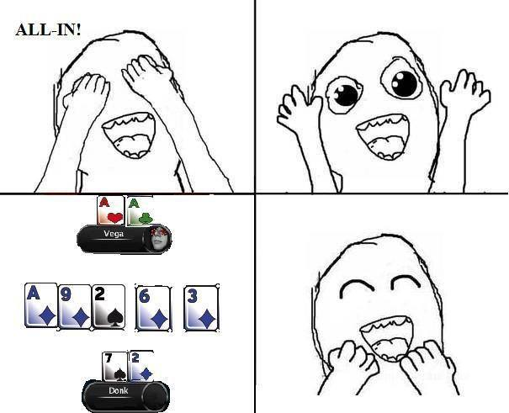

Participants:

Daniel Petrov – danielpetrov1991

Kalin Dimchev – kalin.dimchev

Project Structure:

1. EvHand
   1. EvHand.cs
2. Helpers
   1. HandStrengthValuation
      1. FiftyBigBlindsHandStrengthValuation.cs
      2. HandStrengthValuation.cs
      3. TenBigBlindsHandStrengthValuation.cs
      4. TwentyFiveBlindsHandStrengthValuation.cs
   2. RaiseTwoSevenCardValuationType.cs
3. Statistics
   1. OpponentEvaluationType.cs
   2. OppStats.cs
   3. ReadFromFile.cs
   4. Statistics.cs
4. RaiseTwoSevenPlayer.cs
5. **EvHand.cs**

Evaluates the strength of our hand.

<http://codereview.stackexchange.com/questions/36841/poker-hand-evaluator-challenge>

1. **HandStrengthValuation**

Contains hand ranges, that we are making our decisions, based on. The are ranges for the following count of big blinds in our stack – 0-10 BB, 10-25 BB, 25-50 BB, 50++ BB. There are ranges not only for evaluating the strength of our hand but ranges for decision if it is reasonable to make 3bet, to raise all-in, to call all-in etc.

1. **Statistics**

Every hand, we can extract information from, we build statistics about the behavior of the opponent. For example – how often he checks or raises preflop, how often he plays on flops, how often he calls 3bet etc. According to these numbers we evalulate our opponent as Tight, Wild, Tornado and Solid player. We have enough information for the opponent when we have at least 30-th played hand.

1. **Player Logic**

Flow of making decisions:

First we evaluaten the strength of our hand preflop. It depends on two components – count of big blinds in our stack and our position.

Preflop:

Depends on count of big blinds in our stack we decide how much is reasonable to be our raise. If we are on button and have enough information to evaluate the opponent as Tornato player we raise the precalculated amount of money. If we don’t have we don’t have information we can raise or re-raise if our hand is good enough. Otherwise we fold.

If we are out of position we have few options: If we know that opponents raises preflop too often we can raise all-in or we can raise the precalculated amount. Otherwise we check if it is possible or fold. If the opponent has made 3bet raise we can 4-bet him or raise all-in, depends on how percent of our stack costs this. If our hand is not good enough to call all-in, we fold. If there was 4-bet action from the opponent we can raise all-in again of fold, depends on type of opponent and our stack.

Flop:

We calculate again reasonable amount to raise according to our stack and pot sizes. If we are on position and we have flopped something, we make value bet. If we can’t check and we have flopped nothing, we fold.

Turn and River:

We calculate reasonable amount to raise the same way. We re-evaluate our hand according to the fourth and fifth common card and make decision to raise or fold. The difference is that on river we can’t be on draw.